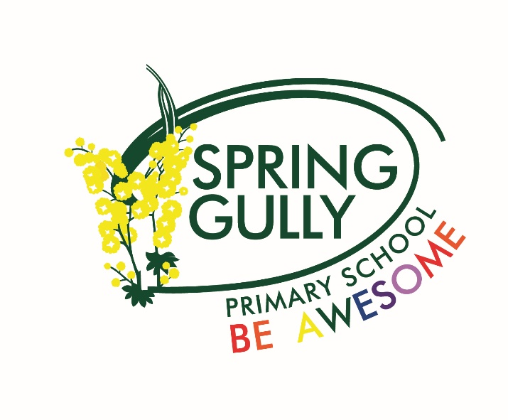

Information Booklet
2027

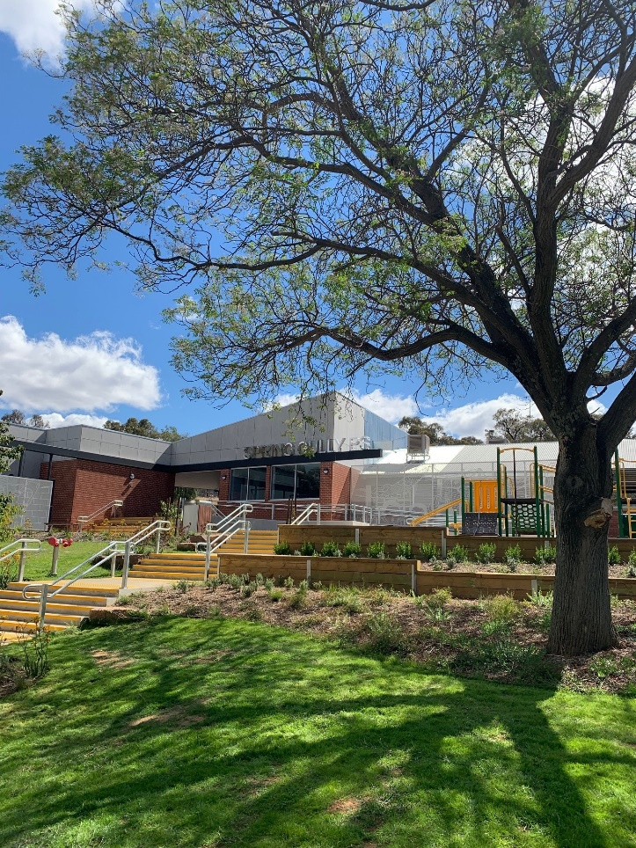

Phone: (03) 5443 7230
Email: spring.gully.ps@education.vic.gov.au
Website: www.sgps.vic.edu.au

104-110 Spring Gully Road,
Bendigo, Victoria, 3550.

WELCOME

Welcome to Spring Gully Primary School

Our school has a rural school tradition with a commitment to excellence and we view education as a partnership between the home and the school. We highly value input from parents.

Whilst it is natural that your child will become more actively involved in the school than you, it is our wish that you will establish regular contact and become involved in the school’s activities at a level comfortable to you. Without parent assistance, many of our school programs would not be able to function effectively.

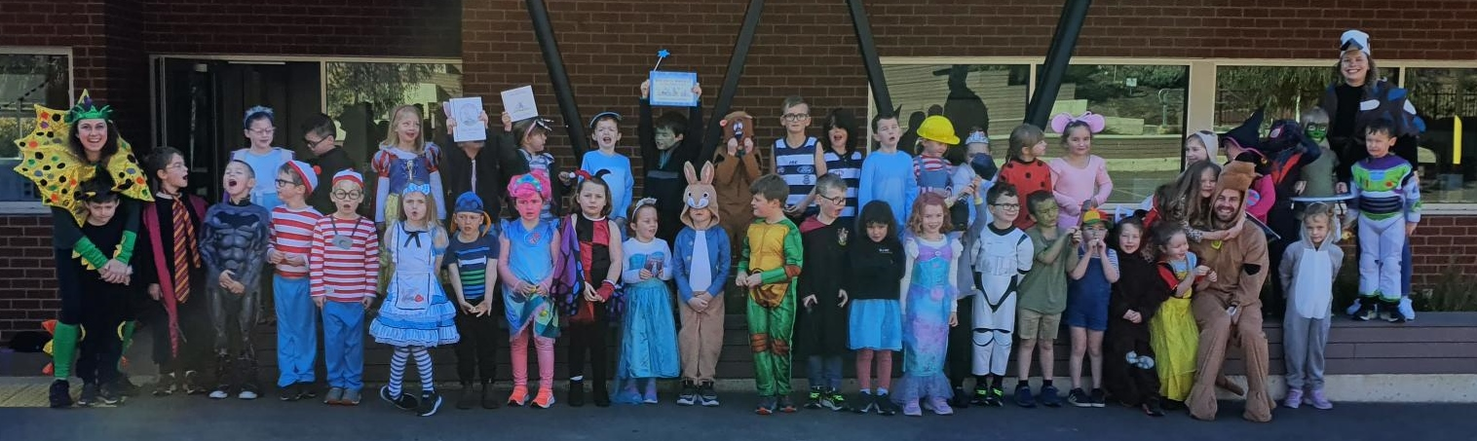
I trust that the information provided in this folder will assist you to understand many of the matters concerning your child, and familiarise you with much of the school’s organisation and operation.

Our Mission

‘To foster a community of learners where everyone is valued and has opportunities to reach their personal best’.

OUR MOTTO: Be Awesome!

OUR VISION:
- Optimistic, resilient students who are motivated to learn.
- Positive, professional staff committed to the challenges of teaching and learning.
- Core curriculum that builds strong foundations for all learners.
- Learning opportunities that enable students to become active citizens in the global community.
- Actively develop and value the partnership between home, school and community.
- A safe, stimulating learning environment which recognises and values diversity.
- Informed students who will actively care for the world environment.

Our SCHOOL VALUES:
Respect:
- Valuing self, all others, property and the environment.

Responsibility:
- Being relied upon to be honest, and do the right thing for yourself and for the community.

Resilience:
- We are dedicated and focused learners, who persist when things are challenging and use feedback to improve our future efforts.

This booklet has been prepared in an effort to make your child’s early and/or first days at Spring Gully Primary School happy, rewarding and pain free.

Beginning a new school can be a little bewildering for children. There are new adults to meet, new friends to make, new rules to learn and new places to see.

Children are helped to settle quickly when parents and friends show a positive attitude towards school. You may do this by:
- Showing an interest in the work your child brings home.
- Talking about school activities.
- Praising your child’s efforts.
- Doing your best not to be critical or compare.

Please make sure your child arrives at school before bell time. This allows time to organise belongings and interact with friends. Classrooms are open from 8:40am. If you need to see your child’s teacher, they are available from 8.30am for a brief chat.

Be sure your child is aware of arrangements for coming to, and being collected from, school. Please try to be punctual, pick a meeting place and keep procedures consistent.

Term Dates 2027
Term 1: Thursday January 28 to Thursday March 25 (staff commence on Wednesday January 27).

Each year government schools are provided with four student-free days for professional development, school planning and administration, curriculum development and student assessment and reporting purposes. Tuesday January 27 is a compulsory student-free day in all government schools. The remaining three student-free days are determined by each individual school.

Prep children will not attend school on Wednesdays during February (3, 10, 17, and 24).

Term 2: April 12 to June 25 Dismissal 2:15pm
Term 3: July 12 to September 17 Dismissal 2:15pm
Term 4: October 4 to December 17 Dismissal 1:15pm

Prep Children Entry Assessments and Transition
Our Prep team conduct their testing at the start of the year, as many schools do. This means the start of 2026 will look as follows for our Prep children:

- Curriculum Day (students not required at school) Wednesday January 27

- Interview Day - Grades 1 to 6 (8:00am-7:00pm) Thursday January 28

- Assessment Day – Preps (8:00am-4:00pm) Thursday January 28
Friday January 29
??

- First Full Day of School! Monday February 1

Completing these assessments in a timely manner will support the Prep teachers in delivering a more accurate curriculum from day one. Prep children will not attend school on Wednesdays during February (unless they have an interview booked on this day). These will be used as ‘rest’ days as the children adapt to school life.
For the remainder of Term 1, parents may keep Prep children at home on isolated days if they feel that school is becoming quite exhausting for their child. The Wednesday is perhaps the best day for this to occur. Parents will be in the best position to make this decision for their own child and are encouraged to discuss this with their child’s teacher.

Absences
For each absence parents and carers are asked to log it on COMPASS, phone the school, or provide a short note. The provision of an absence note is a legal requirement of parents and carers.

- classroom teachers will mark rolls at 8:45am, these rolls are then reconciled with the approved student absences notified to the office.

- parents of children absent without notification will be contacted by phone, letter or an SMS to verify the child’s absence from school that day.

If parents know in advance of a child’s absence from school on a particular day/s then a note/verbal notification prior to the absence will suffice i.e.: there will be no need to ring on the day.

Accident/Illness
If your child is injured or becomes ill and unable to attend classes, you will be advised and asked to collect your child. If we are unable to contact either parent or guardian as listed on our Confidential Student Information records we will then contact the person(s) listed in case of emergency situations. In the event of medical attention being necessary, such assistance will only be sought after efforts to contact parent(s), guardian(s) or emergency contact person(s) have failed.

Assembly
This is held each fortnight on a Friday in the School Hub at 3:00pm (weather permitting). Parents will be notified if their child is receiving an award at assembly. All parents are most welcome to attend.

Awards
Principal Awards
Principal Awards are nominated by the classroom teacher. These awards rotate through the departments within the school. The Principal Awards are based on the School Values and are presented at assembly fortnightly.

GuGu Awards
Students are able to earn GuGu stickers throughout the week by showing our school values Respect, Responsibility and Resilience. Once they collect 25, 50 or 100 they receive a certificate at assembly.

Sports Awards
These awards are nominated by our Health & PE Co-ordinator. Sports Awards are designed to recognize ‘Participation’, ‘Sportsmanship’ and ‘Most Disciplined Player’. Sports Awards are presented at assembly fortnightly.

Auslan, Music and Art Awards
These awards are nominated by our specialist staff to recognize an outstanding effort in these curriculum areas. These awards are presented at assembly fortnightly.


Book Club
Our school participates in Scholastic Book Club. Order forms are sent home approximately every month and children may place orders for books listed. It is requested that completed order forms (with money – cash/cheques made payable to Scholastic Australia/credit card details) be returned to school before the advised closing date. Also, LOOP, the L inked O nline O rdering & P ayment platform, allows parents to order and pay for their child's Book Club requirements in one simple online process. LOOP is our preferred method of ordering.

Books are usually received within 2-3 weeks after ordering. If you would like to assist in processing orders, please advise the library technician, Rachel Connelly.

Booklists and Curriculum Contributions
Parents are requested to provide items listed on the booklist and have their children bring all items to school on the first day of school. Parents have the option of ordering through Education Plus (Ed-Plus) or purchasing the items themselves. If you are ordering through Education Plus, please ensure your orders are submitted by mid December to guarantee delivery for start of Term 1, 2026.
Buddies
Each year the Grade five students are buddied up with the Prep children. The Grade five children help them to find their way around the school during those vital first few weeks. Throughout the year the buddies continue to work together fostering the relationships through weekly activities. The Buddy program continues for the Prep and Grade 5 students in the following year further strengthening the relationships formed through the first year.

Camps / Excursions / Swimming Program
In order for your child to participate, you must complete and sign a medical consent form prior to the activity. This is to be completed via COMPASS, if you require any assistance with this please contact the school.

Change of Clothing
We keep on hand a small supply of clothing for loan to children on those occasions when a change of clothing is necessary. Please note that this clothing is only on loan and should be returned to school as soon as possible after laundering. Where possible we ask that families provide students with a spare change of clothes in their school bag.

Child Safe Standards
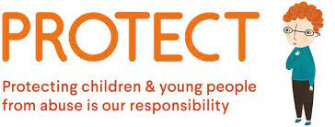
Children have the right to be safe and protected, including at school. Schools and other child-related organisations have an important responsibility for keeping children safe. The child safe standards strengthen existing approaches to preventing and responding to child abuse and aim to create a culture where protecting children from abuse is part of everyday thinking and practice. Spring Gully Primary School is committed to the Child safe Standards.
http://www.vrqa.vic.gov.au/childsafe/Pages/Home.aspx

Children Leaving School Grounds
We ask for your cooperation to explain to children that: -
- they should report to teachers if you have not arrived to collect them on time.
- they must never leave the school grounds during recess and lunch times.
- they must use the school crossing where applicable and we also insist adults use the crossing on Spring Gully Road at all times.

COMPASS – Student Management & Learning System

We use COMPASS as a Student Management and Learning system. COMPASS enables teachers and parents to communicate on all aspects of school life. COMPASS is a vital tool for our community to be engaged with. There are a number of functions you will be using on COMPASS as a parent of Spring Gully Primary School:
- View your child’s profile and have ‘anytime access’ to a range of different information about your child, including their attendance, medical and class details
- Stay informed by receiving notifications from the school, such as information about events and accessing our weekly school and class newsletters
- Provide permission and pay for camps, sports and excursions
- Access your child’s Learning Tasks, as part of our progressive reporting to families
- Receive your child’s bi-annual Semester Reports
- Communicate with your child’s teacher and/or any other staff member at our school
- Inform the school about upcoming or past absences
- View the SGPS Community Calendar
- Keep your details update including your registered email and mobile number (used for SMS alerts).
COMPASS can be downloaded via the App Store or Google Play for both Apple and Andriod devices. Families can also log onto via a web browser https://sgps-vic.compass.education/. If you are a new family to Spring Gully you will be provided with your personal COMPASS access details at the start of the school year or at the time of your confirmed enrolment.

CSEF Payments
CSEF payments (Camps, Sports, Excursions Fund) are available to families who hold a concession card. Forms are available at the office. These forms must be lodged at the office with a copy of your concession card before the end of term 2. This money is directly deposited into your school account and is only for payment for camps, sporting activities or excursions.

Curriculum
The Victorian Curriculum will give students the skills they need for work and life: literacy, numeracy, scientific knowledge and skills, resilience, respectful relationships, the use of digital technologies and the capacity for critical and creative thinking and expression. Refer to appendix A.

Dogs
Family members are welcome to bring their dog to school as part of their usual routines i.e. when walking their child to school or when picking them up at the end of the day, however, they must be kept on a lead at all times. Stray dogs found on school grounds will be handed over to the Municipal Authorities.

Family Law Court Orders
We require information about parents, guardian or carers so that we can take account of family arrangements. Family Law Court orders setting out any access restrictions and parenting plans should be made available to us. Please tell us as soon as possible about any changes to these arrangements. If you would like to discuss, in strict confidence, any matters relating to family arrangements, please contact the Principal.

Fresh Fruit Friday
Thanks to the generosity of McKerns and our wonderful Parent helpers, our very popular Fresh Fruit Friday program continues to operate. All students have access to fresh fruit every Friday morning.

Grade 6 Graduation Ceremony
This is a formal evening for Grade 6 children and their families. The ceremony is held mid/late December.


Hats and Sunscreen
In the warmer weather please encourage students to protect themselves against the sun by wearing sunscreen and a hat. Sun safe hats are a compulsory part of the school uniform and must be worn from mid-August until the end of April when the students are in the playground, during morning and afternoon breaks, during sports and other outside activities.

Head Lice
The school’s Head Lice Policy and procedures assist in keeping head lice infestation amongst the student population at a minimum. Constant vigilance and attention is required by parents. Please notify the school in the event of infestation so other families can be advised to take extra care. Head lice are not a sign of uncleanliness so no embarrassment should be felt about notifying the school.

Infectious Diseases
Some infectious diseases preclude students from attending school. A list of infectious diseases can be found in attachment B.

Late
Parents are requested to sign in at the office if their child/ren arrive at school after 8:45am. Children are to collect a late pass from the office to hand to their classroom teacher. Parents of children who have unapproved late arrivals will be contacted by letter/SMS asking for confirmation of the reason for the late arrival.

Leaving Early
Parents wishing to take their children from school early should give the school prior notification, preferably by email to the classroom teacher or telephone call advising time of collection and name of adult collecting the child. When collecting children at any time during the day, the student must be signed out at the office. Photo identification may also be required. If children are returned to school then they must be signed back in. Under no circumstances are pupils permitted to leave the school grounds during school time without the above procedures being followed.

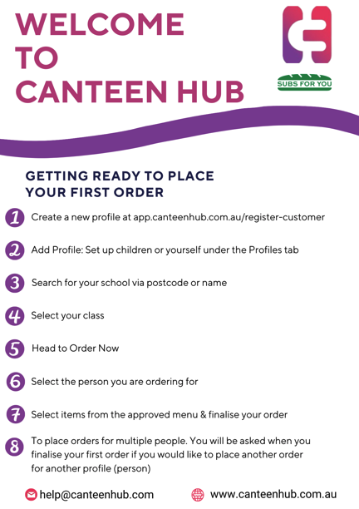
Lunch Arrangements
Pupils who have their lunch at school eat it under the supervision of teachers. No child is permitted to play during this time. We would suggest that parents encourage their child to bring uneaten lunch home again, so that quantities and preferences can be ascertained.

Students are not permitted to share food. At Spring Gully Primary School we encourage healthy eating. Healthy eating has a long-lasting and positive impact on a child’s growth, development and health. Foods eaten by your child at school contribute greatly to their daily nutrient intake. These foods considerably influence their eating habits, growth patterns, energy, concentration levels and ability to learn. You have an important role to play in helping to ensure your child eats well and stays active.


We encourage students to bring ‘fruit snack’, which can be consumed during class time, at the discretion of the teacher. This food must be fruit or vegetables, peeled and cut up if necessary, ready to eat. No processed foods are permitted during class time. We also encourage all students to bring their own water bottle to school. This should only contain water.

On Thursdays we offer pre-ordered lunch orders through an app Canteen Hub (SUBWAY) who deliver to school.

Medication Sent to School
In most circumstances students are not permitted to self-administer medication at school. If self-medication is required, e.g. Ventolin, ensure that the First Aid Officer and your child's teacher have been informed in writing and that your child is competently able to self-administer. Medication must always be accompanied by written signed instructions. At the request of parents, prescription medications will be securely kept in the office and administered by the School’s First Aid Officer.
Asthma Management Plans, Anaphylaxis Plans and other medical plans must be provided to the First Aid Officer on or before the first day of school.

Money Sent To School
Where possible, our preference is for parents to use COMPASS to make payments (and provide permission) for excursions, camps, sports days, etc.

If money is sent to school it should be sealed in an envelope and clearly marked with:-
Child’s Name
Grade and Class
What the Payment is for

NB: We also have EFTPOS, BPAY and COMPASS.
Please contact the office for your family reference number if you wish to use BPAY. After you have made a BPAY payment, please notify the office of the amount paid and the activity paid for.
Newsletters

School newsletters are distributed electronically via COMPASS to parents fortnightly, on a Thursday. It is important that parents read the newsletters carefully, as it is an important form of communication used by the school to keep parents informed.
School newsletters can also be accessed on the school’s website www.sgps.vic.edu.au

Outside School Hours Care (OSHC) & Vacation Care

At Spring Gully we have before and after school care with our provider Camp Australia. Camp Australia provides a fun, safe and engaging OSHC program in partnership with Spring Gully PS for our school community.
Established in 1987, Camp Australia offers a range of services in child care, sports coaching and events. They currently run OSHC programs in over 300 schools, including a number in the local region.
Before using the program, you need to register for an account. This enables you to make bookings, view your statements and manage your details anytime of the day. Registering is quick and easy. Visit www.campaustralia.com.au/newparents to begin.

Information packs are available for new/prospective families at the office.

Parents’ Club
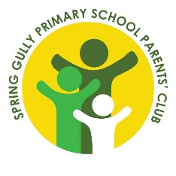
Parents’ Club is a network of parents who manage fundraising opportunities and social activities for parents and families within our school community.

Aims and Objectives
• to contribute to the wellbeing of the school community
• to encourage the participation of parents in the life of the school and the education of their children
• to provide opportunities for parents to get to know each other
• to work in co-operation with School Council and the Principal
• to raise funds for the benefit of the school.

Committee Positions
The following positions are declared vacant at the AGM at the beginning of each year.
• President/s • Vice President
• Secretary • Treasurer

Parent / Carers Participation

There are many ways parents can be involved in the school – Parent Club, School Council, making teaching aids, library maintenance, weekend sport, reading, typing, excursions, camps, sports days etc.

Parent volunteers are required to have a current Working with Children (WWC) Check. A Working with Children (WWC) Check is valid for 5 years.

To apply for a Working with Children (WWC) Check you can go to https://www.workingwithchildren.vic.gov.au/individuals/applicants/how-to-apply

What you will need to fill in the online application form
To complete the form you must have:
an email address, so we can contact you about your application
- the address of every place you have lived in the last 5 years in Australia
- the name, postal address and phone number in Australia for each organisation you will be doing volunteer child-related work for
- a printer that will print a legible copy of the Application summary.
After filling in the online form, finalise your application at a participating Australia Post retail outlet, by presenting your Application summary, proof of identity documents and a passport quality photo. There is no cost to obtain a volunteer WWC Check.
Visit http://www.workingwithchildren.vic.gov.au/ for further information

Pick up
At 3:30pm, any children still remaining at school will be sent to the front steps by the teacher on duty. They will be supervised there until 3:45pm.

Students that are not collected by 3:45pm will be placed into the Outside School Hours Care program and parents will be charged for this service by Camp Australia.

The crossing supervisor is on duty from 8:00am to 8:45am and from 3:00pm to 3:45pm.

Respectful Relationships
At the beginning of 2017 we were selected as one of the Leading Schools across the state, and the only primary school in the Bendigo region, for this ground-breaking and transformative initiative to prevent family violence and promote gender equality. Respectful Relationships Leading Schools have been collaborating with the Department of Education & Training and other schools for the last couple of years to build and sustain school cultures of respect and gender equality – both as learning places and as workplaces that aim to achieve long-term change in the community.

In order to implement a whole school approach to Respectful Relationships, our school has:
- established a team to implement the Respectful Relationships initiative
- undertaken a school gender equity assessment to highlight areas of need
- developed and implemented a whole school Respectful Relationships plan that includes:
  - actions to promote gender equality across the school community
  - strategies to promote gender equality across the school workforce
  - delivered respectful relationships as part of the Victorian Curriculum
  - released staff for professional learning
  - supported staff and the school community to build their understanding of Respectful Relationships and its role in preventing gender-based violence
  - supported 12 other local schools to implement the Respectful Relationships initiative at their school.
  - engaged with community family violence support and response services.

We were very proud to have been selected to lead an initiative as important as this. We are even prouder to now be acknowledged as a ‘Showcase’ school with the Department of Education for our work in this area. Please see the link below for further details.

https://www.education.vic.gov.au/about/programs/Pages/respectfulrelationships.aspx

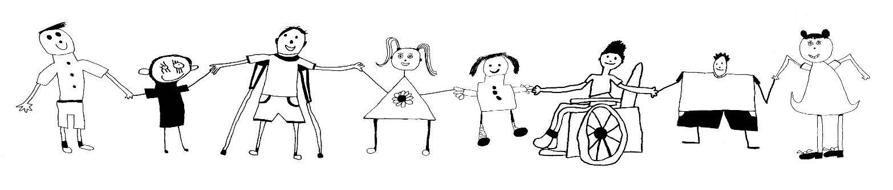

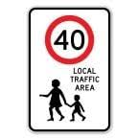
Road Safety
- SPEED SIGNS
The speed limit in front of the school along Spring Gully Road is 40kph from 8:00am to 9:30am and from 2:30pm to 4:00pm.
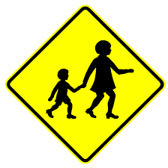
- SCHOOL CROSSING
Children crossing Spring Gully Road should do so at the crossing provided. We ask adults to also use the crossing even if the crossing is unsupervised.

- CAR PARKING
Please use parking facilities outside the school grounds. There is plenty of parking at the back of the school in Walker Drive which parents may find less congested than Spring Gully Road. Walker Drive is a 40kph zone and care should be taken there also.

School Wide Positive Behaviour Supports (SWPBS)
School-Wide Positive Behaviour Support (SWPBS) is a whole-school framework which provides school professionals with an approach to promote improved behaviour and student wellbeing.
SWPBS has been developed from evidence and data, demonstrating the most effective ways to prevent and respond to problem behaviour at school. Research has shown that SWPBS is successful in reducing problem behaviour, improving school culture, and increasing academic performance.

School Houses
In 2006, Spring Gully Primary School celebrated 100 years of education in Spring Gully. Part of the centenary process was to introduce school houses. The school has named six houses after special contributions and/or achievements by past students and staff and a community member. The houses are:

ASHBY (White)
Glenn Ashby, a former student, is a multiple World Champion Yachtsman. Glenn has won many world titles and the number continues to grow.

GODBER (Green)
Gail Godber our former music teacher. Gail brought a very musical flavour to Spring Gully PS.

HARLEY (Yellow)
Alfred Harley was the first principal of Spring Gully PS.

POLLOCK (Blue)
Carmel Pollock, our very much respected school crossing lady, was recognised for her contribution to the ‘welcoming’ aspect of our school. When she was at school on the crossing Carmel greeted everyone with a smile every morning!

SAVAGE (Black)
Padraig (Patrick) Savage, a former student, is the principal or lead violinist for the Royal Philharmonic Orchestra.

TINGAY (Red)
Steven Tingay a former student, is an astrophysicist and leads a scientific unit at Monash University.

Students are placed in school houses randomly, although siblings are kept together. The house system increases a sense of belonging as well as increasing leadership opportunities.

Social Service
As pupils are encouraged to take an interest in and assist those less fortunate than themselves, they are asked to contribute to charitable appeals from time to time. The Student Representative Council members generally organise these appeals.

Social Worker
Spring Gully Primary School currently has a Social Worker working with us Monday to Thursday. Our Social Worker is available to assist parents with welfare and wellbeing issues, including supporting students who may be experiencing loss or grief due to separation, divorce, illness or death of a loved one. Our Social Worker has extensive knowledge of support systems available to parents. If you need to talk to the Social Worker for any reason, the office staff will be able to assist you in making contact.

School Bus
Families who reside at least 4.8km from Spring Gully Primary School are eligible to travel on the bus as long as Spring Gully Primary School is your nearest school. An “application to travel” form must be completed and lodged before using this service. You will be advised of the outcome of your application. This is now all done online via Public Transport Victoria. Please enquire at the office for further information.


School Photos
Our school photos are taken by Leading Image in Term 1. Packages are to be ordered and pre-paid directly to our provider. They range in price from approximately $25.00 to $45.00.

School Readiness – Preps
Refer to Appendix C

School Times
Time | Activity
8:40am | Classrooms open
8:45am to 10:45am | 1st block
10:45am to 11:30am | Lunch
11:30am to 1:30pm | 2nd block
1:30pm to 2:15pm | Recess
2:15pm to 3:15pm | 3rd block / dismissal
3:30pm | teachers finish back of school duty – students brought to office
3:45pm | teachers finish front of school duty – country bus picks up

Pupils are expected to arrive punctually for all school sessions and parents are asked to ensure that children are sent to school on time and picked up at 3:15pm. There is a teacher on duty from 8:30am to 8:45am and two teachers are on duty from 3:15pm to 3:30pm.

In the event of extreme fire danger, there is no provision for the closure of schools unless a directive comes from the Department of Education and Training to close. However, we do have strategies in place to ensure the safety of all children whilst we remain open.

School Uniform
The wearing of school uniform is compulsory at our school. Our school uniform is available from Noone (pronounced ‘Noon’). They have a retail store at 21 Queen Street, Bendigo (opposite Officeworks carpark). The wearing of a school uniform is important from the point of view of the child “belonging” to the school. In this sense, your child is more likely to take pride in appearance and in the school to which they belong. Please ensure that your child’s clothing and belongings are clearly and permanently marked. Tracing ownership in a school of this size can be an impossible task if articles are not named. An identifying sign is not sufficient to enable us to trace owners. Please notify your child’s teacher if you find some article of clothing is missing. Unclaimed property is disposed of from time to time (usually at the end of a term). Lost property can be located near the office.

Student Safety
From the point of view of the safety of your own child and the welfare of others, it is important that your child knows and follows the basic rules of safety. Parents are asked to ensure that children observe the following: -

- All pupils should know their own full name and address.
- Pupils should travel the most direct route between school and home.
- All pupils should know the kerb drill - “look right, look left, look right again. If safe, cross quickly, do not run”.
- School Crossing should be used whenever possible.
- The footpath should be used where provided.
- Children should never run from behind parked cars or buses.
- It is most important that children never accept rides from strangers.
- Articles likely to cause accidents should not be brought to school. These include glass containers, knives, razor blades, fireworks, guns, syringes, water pistols and matches.
- We cannot accept responsibility for loss or damage to toys brought to school.
- All pupils should be taught to respect those in charge of their safety - teachers, bus drivers, police, neighbours, parents acting as escorts etc.

.
Transition Program 2026

Tuesday, May 12 2026
Prospective Parents Information Night 6:30pm – 7:30pm

Tuesday, November 10 2026
Confirmed Enrolments Information Session for 2026 Prep Parents 6:30pm - 7:30pm

2026 Prep Children Orientation Program Dates
Tuesday, November 17 2026 9:00am -10:00am
Tuesday, November 24 2026 9:00am -10:00am
Tuesday, December 1 2026 9:00am -10:00am
Tuesday, December 8 2026 9:00am -11:30am

APPENDIX A: CURRICULUM

English
At Spring Gully Primary School literacy instruction is an integral part of each day. Our program ensures the explicit teaching of key areas Reading and viewing, Writing, Speaking and Listening as outlined in the Victorian Curriculum.

We recognise that the most up to date research has shown there are six key components to teaching reading including:
- Oral language
- Phonemic awareness
- Phonics
- Fluency
- Vocabulary
- Comprehension
Our students engage in activities daily designed to foster their learning in each of the 6 areas, including regular exposure to knowledge rich texts and the development of vocabulary.

Big Write & VCOP
VCOP and Big Write is a teaching approach based on the research of Ros Wilson, an expert based in the UK. It focuses on four main aspects of the writing process (VCOP) and provides children with the skills to improve their own writing through self-assessment. We will have four mascots that represent each section of VCOP.

Big Write:
Big Write will be a celebration of students’ learning. This will be conducted after a VCOP session. The biggest difference between Big Write and the ‘everyday’ writing session is the environment. The classroom will have a different atmosphere. The lights will be dimmed, candles will be burning (we will probably use LED candles) and quiet music will be playing (Mozart is recommended). Students will not be allowed to talk to each other and the teacher will take this time to conference with students one to one and look at their individual goals.
Prior to most Big Write sessions, ‘Talk Homework’ will be sent home to allow the students opportunities to talk about their writing.

Cold Writes:
A ‘Cold Write’ is a writing session where students are not given the opportunity to talk about the topic before writing and the learning aides (dictionaries, word charts and displays) are removed. This will be an opportunity for students to display what they know without the assistance from external resources.

Talk Homework:
‘Talk Homework’ will be sent home the evening before a Big Write session to allow the students opportunities to talk about their writing, gain ideas from family and friends, and to assist in making the most out of their Big Write session.

Soundwaves
The Soundwaves program provides a whole-school systematic phonics approach to teaching spelling. This approach is recognised as one of the most effective ways to teach spelling and reading skills.

Art / Craft
We have a specialist art/craft program with a fully equipped art room, which includes a kiln for firing clay. All children receive a specialist lesson each week.

Digital Technology
Children from Prep to Grade 6 have access to different forms of technology which they use to gather information, present their work, support learning, create, problem solve and develop general technology skills. Using a range of programs and website, students have the opportunity to present work in different formats. Students access the internet and utilise programs to gather information, undertake skill building and assessment activities, communicate via email and generally support their learning. Students create animations, engage in coding and robotics and use digital video cameras to make simple movies. Spring Gully P.S. has large TVs in all classrooms for teachers to demonstrate learning visually. Students in Grades 3 - 6 participate in the 1-1 Netbook computer program. Students are able to take their netbook home, continuing the partnership that exists between school and home. Junior school students have access to netbooks and iPads. The school adheres to eSmart guidelines and has a Cybersafety Policy in place.

Humanities
This program is planned on the belief that one of our roles is to help children grow as active, contributing and thinking people of our society. It is aimed to develop a framework of understanding of the changing social world and each individual’s place within it so that he/she copes with the needs of social living.

Languages Other Than English (LOTE)
All children in grades prep to six study LOTE. We currently offer AUSLAN with students attending a 1 hour session with their class each week.

Library
Our school is fortunate in having a fully automated library to assist in carrying out the educational aims of the school program. Materials in the library are in a wide range of difficulty levels, thus enabling the needs of the individual child to be met. An important part of the library’s role is the borrowing of books, and parent encouragement and co-operation in this area would be appreciated. As may be expected, some rules are essential for the care of books that are borrowed. Parents are requested to ensure that children care for books that are taken home, and should contact the librarian if books are badly damaged or lost. Assessment can then be made of the amount payable to replace the book. Minor damage can, and should, be reported by the child. If parents ensure that books are returned promptly when read, damage or loss is less likely to occur. Parents are asked not to attempt to repair books, as we use special requisites for this task. All pupils may borrow books. The loan period is two weeks.

Mathematics
Our Mathematics program concentrates on problem solving and real world type activities. Students concentrate on mental strategies and are asked to talk about processes used to solve problems. We are fortunate to have developed a rich resource of materials and aids to enrich our program.

Music
All classes have music on a weekly basis. These lessons cover singing, playing, moving, creating and listening activities. Children with interest and ability in music may also join the school choir which practises at school each week.

Physical Education/Sport
Our aim is to provide all children with basic skills in a wide range of activities. All children at Spring Gully Primary School participate in a Physical Education Specialist Program, as well as class Physical Education lessons. There is much opportunity for older students to represent the school in a variety of sports.

Science and Technology
Investigative skills are encouraged by an emphasis on measuring, experimenting and interpreting information. Pupils are led to recognise relationships, concepts and patterns of change within the environment. The school has built up a collection of science and technology equipment and references, to facilitate the attainment of these aims.
An appreciation and respect for our environment is encouraged through our vegetable garden and native sanctuary.

APPENDIX B: INFECTIOUS DISEASES

Please refer to the following table that indicates the minimum period of exclusion for infectious diseases.

Exclusions from school
Principals are required to exclude students according to the following table under the Health (Infectious Diseases) Regulations 2001.
Note: The regulations require the parent/guardian to inform the principal as soon as practicable if the child is infected with any of the diseases listed in the table, or has been in contact with an infected person. It should be noted that in cases of diphtheria, typhoid and paratyphoid fever, exclusion and determination of recovery will be matters for the municipal medical officer of health.
‘Contact’ means child of school age or preschool age living in the same house as the patient or who has been in association with an infected person or a contaminated environment.
‘Patient’ includes carrier.
‘School’ includes any preschool centre, kindergarten, primary or secondary school.
Patients or contacts shall be prevented from attending school unless they comply with the conditions hereunder prescribed.
It should be noted that during outbreaks of diseases prescribed in the table, Principals are to direct parents/guardians of students who are not immunised to keep their children at home for the recommended period. Minimum period of exclusion from schools and children’s services centres for infectious diseases cases and contacts
In this schedule ‘medical certificate’ means a certificate of a registered medical practitioner.
Conditions | Exclusion of cases |  | Exclusion of contacts
Amoebiasis (Entamoeba histolytica) | Exclude until there has not been a loose bowel motion for 24 hours |  | Not excluded
Campylobacter | Exclude until there has not been a loose bowel motion for 24 hours |  | Not excluded
Chicken pox | Exclude until all blisters have dried. This is usually at least 5 days after the rash appears in unimmunised children, but may be less in previously immunised children. |  | Any child with an immune deficiency (for example, leukaemia) or receiving chemotherapy should be excluded for their own protection. Otherwise not excluded
Conjunctivitis | Exclude until discharge from eyes has ceased |  | Not excluded
Cytomegalovirus infection | Exclusion not necessary |  | Not excluded
Diarrhoea | Exclude until there has not been a loose bowel motion for 24 hours |  | Not excluded
Diphtheria |  | Exclude until medical certificate of recovery is received following at least two negative throat swabs, the first not less than twenty-four hours after finishing a course of antibiotics and the other forty-eight hours later |  | Exclude family/household contacts until cleared to return by the Secretary
Conditions |  | Exclusion of cases |  | Exclusion of contacts
Glandular fever (mononucleosis) |  | Exclusion is not necessary |  | Not excluded
Hand, foot and mouth disease |  | Exclude until all blisters have dried |  | Not excluded
Haemophilus type b (Hib) |  | Exclude until at least 4 days of appropriate antibiotic treatment has been completed |  | Not excluded
Hepatitis A |  | Exclude until a medical certificate of recovery is received, but not before seven days after the onset of jaundice or illness |  | Not excluded
Hepatitis B |  | Exclusion is not necessary |  | Not excluded
Hepatitis C |  | Exclusion is not necessary |  | Not excluded
Herpes (“cold sores”) |  | Young children unable to comply with good hygiene practices should be excluded while the lesion is weeping. Lesions to be covered by dressing, where possible |  | Not excluded
Hookworm |  | Exclusion is not necessary |  | Not excluded
Human immuno-deficiency virus infection (HIV/AIDS) virus) |  | Exclusion is not necessary |  | Not excluded
Impetigo |  | Exclude until appropriate treatment has commenced. Sores on exposed surfaces must be covered with a watertight dressing |  | Not excluded
Influenza and influenza like illnesses |  | Exclude until well |  | Not excluded unless considered necessary by the Secretary
Leprosy |  | Exclude until approval to return has been given by the Secretary |  | Not excluded
Measles | Exclude for at least four days after onset of rash |  | Immunised contacts not excluded. Unimmunised contacts should be excluded until fourteen days after the first day of appearance of rash in the last case. If unimmunised contacts are vaccinated within seventy-two hours of their first contact with the first case, or received NHIG within 144 hours of exposure, they may return to school
Conditions | Exclusion of cases |  | Exclusion of contacts
Meningitis (bacteria) | Exclude until well |  | Not excluded
Meningococcal infection | Exclude until adequate carrier eradication therapy has been completed |  | Not excluded if receiving carrier eradication therapy
Molluscum contagiosum | Exclusion not necessary |  | Not excluded
Mumps | Exclude for nine days or until swelling goes down (whichever is sooner) |  | Not excluded
Parvovirus (erythema infectiousum fifth disease) | Exclusion not necessary |  | Not excluded
Poliomyelitis | Exclude for at least fourteen days from onset. Re-admit after receiving medical certificate of recovery |  | Not excluded
Ringworm, scabies, pediculosis (head lice) | Exclude until the day after appropriate treatment has commenced |  | Not excluded
Rubella (German measles) | Exclude until fully recovered or for at least four days after the onset of rash |  | Not excluded
Salmonella, Shigella | Exclude until there has not been a loose bowel motion for 24 hours |  | Not excluded
Severe Acute Respiratory Syndrome (SARS) | Exclude until medical certificate of recovery is produced |  | Not excluded unless considered necessary by the Secretary
Streptococcal infection (including scarlet fever) | Exclude until the child has received antibiotic treatment for at least twenty-four hours and the child feels well |  | Not excluded
Trachoma | Exclude until the day after appropriate treatment has commenced |  | Not excluded
Tuberculosis | Exclude until receipt of a medical certificate from the treating physician stating that the child is not considered to be infectious |  | Not excluded
Typhoid fever (including paratyphoid fever) | Exclude until approval to return has been given by the Secretary |  | Not excluded unless considered necessary by the Secretary
Verotoxin producing Escherichia coli (VTEC) | Excluded if required by the Secretary and only for the period specified by the Secretary |  | Not excluded
Whooping cough (Pertussis) | Exclude for twenty-one days after the onset of cough or until they have completed 5 days of a course of antibiotic treatment |  | Contacts aged less than seven years in the same room as the case who have not received three effective doses of pertussis vaccine should be excluded for fourteen days after the last exposure to the infectious case, or until they have taken five days of a course of effective antibiotic treatment
Worms (intestinal) | Exclude until there has not been a loose bowel motion for 24 hours |  | Not excluded

Headlice - Additional Information for Treatment
Headlice in schools can cause some concern and frustration, particularly to the parents who have treated their child’s hair and then have their child reinfected. If headlice are present, please use the conditioner and fine tooth comb treatment or obtain the appropriate treatment from the chemist and carefully comb out the eggs, as well as the lice themselves.

Signs to look for:
- frequent head scratching.
- a fine black powder on the pillow (this is louse faeces).
- paler coloured material on pillows (this is cast off lice skin).
- the lice themselves.
- tiny white specks stuck near the root of hair (these are the “nits” or lice eggs).

After treatment, use a fine toothed comb or your fingernails to clear the head of dead lice and nits.

TWICE A WEEK CONTROLS HEAD LICE!
CONDITIONER AND A NIT COMB - THE SOLUTION TO REINFECTION

If all children or adults at risk put conditioner on their hair once a week and comb it out with a fine tooth comb, head lice would become a minor problem. Older kids can do this, but will need the encouragement of parents. Younger children will need parents to do this for them.

Conditioner and a fine tooth comb is a cost-effective way to stop head lice re-establishing themselves.

Used once a week it can get rid of that reinvading louse. Apply conditioner to dry hair or even wet hair and comb off all the conditioner with a fine tooth comb. Look for lice and eggs by wiping the combings on paper tissue. If you find less than 5 lice, repeat the conditioner and fine tooth combing daily until all lice are gone. If you find more than 5 lice, use an insecticidal treatment. Remember to retreat in 7 days, and to use conditioner and fine tooth comb at least twice between treatments.

APPENDIX C: SCHOOL READINESS PREPS


This section of the booklet is designed to answer any questions you may have about your child before he/she starts the Prep year. It contains some helpful suggestions and a list of things to remember before the “big” day.

Beginning School
As the time gets close for the child to start school, there a number of things which parents can do to help their child settle in easily.

Here are some ideas: -
- Walk with your child to school so that he/she knows the way. Even if you plan to drive most days, it’s a good idea for a child to know which way to walk home.

- Point out the different school buildings and playground areas.

- Once school starts, make sure your child knows where to meet you.

- If children are to feel secure, it is important that they are met on time.

- Practise with the child what he or she should say when asked his or her name or address.

- Label any clothes the child may take off, and items like lunch boxes and school bags. Show your child the label and say something like, “See, I have put your name here in blue pencil”.

- Talk about how long the school day will be in a way that the child can understand. “It’s as long as kinder, but you will have your lunch after that and perhaps some stories/activities and then I will come and get you”.

- Talk about the difference between “playtime” and “lunchtime”. Show your child which food you have packed and say when you expect it to be eaten. Make sure your child can easily open the lunch box and drink container. Individually wrapped sandwiches are easier to handle.

- Choose a school bag or case that is a suitable size for your child. Bags that are too big are awkward and tiring.

Parent/School Relationships
The first day of school can mark the beginning of a clear division between home and school for a child. On the other hand, parents and the school can work together in the interest of the child.

You can help your child make this transition by-
- visiting the school to ask about enrolment well before the child is due to start.
- finding out how to contact teachers if you want to tell them something about your child or discuss his or her progress.
- asking how you may join in school affairs.
- asking if there are things that can be done at home to help the child’s progress at school.

If you don’t know what Prep classes are like, try to arrange a visit to the school and bring your child along. You could talk with the teachers about what they are teaching the children and the reasons for some of their methods.

Parents’ Feelings
The emphasis has been on preparing a child for school, but parents have to be prepared too; prepared for the fact that they may miss their child greatly. No longer will they be the main source of wisdom in the child’s life; the teacher will have some influence too. Most parents accept this as a part of a long-term process in helping the child move from total dependence to independence. They accept any mixed feelings about their child’s independence and many even find that they have some time for new activities.

What Is The Prep Year?
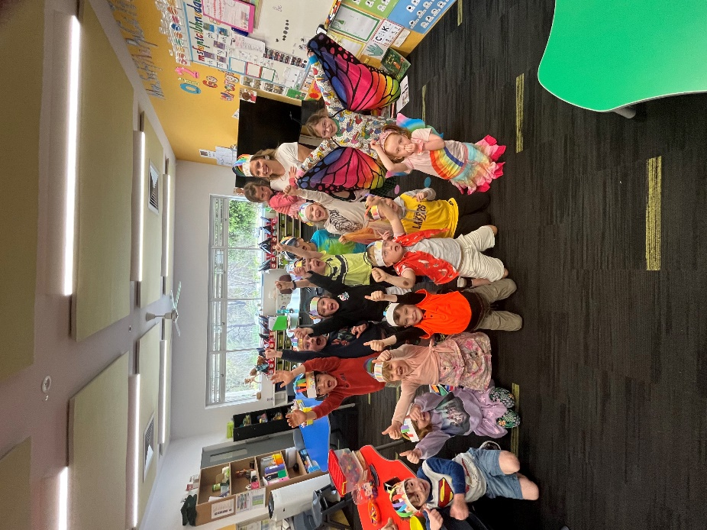
The Prep year is the introduction a child has towards formal learning. It is a very busy year for your child, a year when he/she learns a multitude of things from tying a shoelace to reading and writing. The Prep year is a socially important year. Your child learns how to interact with other students, use correct manners and learns to accept responsibility for his/her own actions, i.e.: putting out the paints and tidying up own work area. Prep children experience what it is like to be a member of a grade learning to work in groups, pairs, individually and as a class.
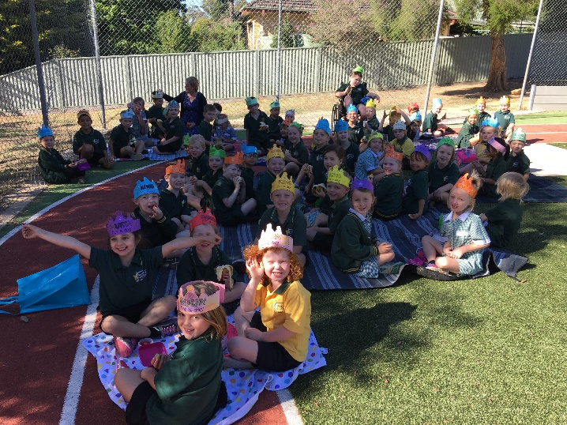

How Children Learn Language
- Children’s language skills develop through their everyday experiences of speaking and listening, asking and answering questions and through supportive opportunities to practise reading, drawing and writing together.
- Encourage children in lots of meaningful conversations about their everyday life, as this establishes a valuable foundation of knowledge and words, essential to their future reading and writing.
- Reward and celebrate all early attempts to read and write.
- Read “to” children and “with” them, as well as providing “read alone” time.
- Use the print on signs, books, advertisements, labels etc. to talk about letters- what they look like and what they sound like.
- Play lots of “I spy with my little eye” to establish understanding that letters make sounds when you say words.
- Write notes, letters, stories and shopping lists etc. together, allowing your child to write what he/she knows. Slowly say words as you write, to demonstrate that letters written are also sounds heard.
- When you read “to” children, use a fluent and expressive storytelling voice, and expect their reading to eventually sound like talking too. Read a familiar book several times to practise this skill.
- Show children using familiar words how some words can be “sounded out”, but this is a complex skill gradually learned over time, so avoid expecting young children to know how to solve new/tricky words this way alone.

Mathematics
Mathematics learning is based, as much as possible, on real life, e.g. “I wonder how many eyes are in this room. Let’s count, or is your row of blocks longer than hers? Let’s measure and find out”.
Children must learn the meaning behind symbols through “objects” before they can handle the symbols with understanding. When you are with your children, take any opportunity to use maths for real life situations. Count, measure, weigh, buy, estimate, and where you can, let your child be involved, so he/she can see the need for these skills.

- Already, your child’s most important learning has taken place before even beginning school.
- It is widely acknowledged that you as parents are the main educators of your children.
- Parents and teachers share a responsibility in each child’s learning.

Number
Children learn how our number system works, how to solve every day problems using addition, subtraction, multiplication and division, and usage of fractions, decimals and percentages.

Measurement
Through use of concrete materials, children learn techniques for measuring length, time, capacity, weight, area, temperature and volume.

Spatial Relations
In this study, children learn about common shapes. This involves them in drawing, cutting out, folding, colouring and handling concrete materials.

What Can Parents Do?
Encourage children to make use of every day family activities, such as cooking, shopping, playing games which involve keeping scores, calculating journey times and so on. Choose one activity per day. It should only take a few minutes.

Words That Can Be Used:
Under/over, heavy/heaviest, more/less, big/small, long/short.

Counting:
Knives and forks when setting the table, pieces of cake, people and change from shopping.

Shopping:
How many things can I buy with $1.00?

Measuring:
Which jar holds the most?
How can you tell?
Who’s the tallest?
How many footsteps to the letterbox?
How many marbles fill the bag? Will 6 cars fit in?

Expectations

Preps should at the end of the year:

- have an understanding of numbers 1-20 (count to) write and recognise numerals, at least
- be able to complete simple jigsaws and patterns, using shapes and blocks.
- know colours, shapes and sizes.
- be able to sort, classify group colours, shapes and sizes, numbers.
- possess an understanding of mathematical vocabulary e.g. short, tall, in, out.
- use a pencil and hold it correctly.
- use scissors and glue correctly, put away after use.
- know how to look after books - show understanding of directionality (reading left to right), what print is, what a sentence is, simple punctuation.
- recognise letters and sounds of alphabet, be able to read simple sentences, recognise common words: and, this, is.
- know what a sentence is and how to write a sentence.
- be aware of health routines - brush teeth, comb hair.
- be able to take home a reading book nightly, be aware of when to select a new book, where to place books - reading boxes and ability to use.
- ask questions (put up hand) if the child wants to go to the toilet, needs something.
- is able to listen carefully to teacher instructions, listen to other children’s comments.
- take home important notices to parents in school bag.
- be aware of simple routines in the classroom.
- lining up to go outside or to another room in correct manner.
- returning library books responsibly.
- tie shoelaces.
- putting away equipment in room in the correct manner after use.
- display correct manners at all times - receiving, giving, sharing and caring.
- be aware of acting responsibly according to classroom rules and routines.
- be aware of where the office is, the toilet, the playground, points of interest, playground rules and routines.
- be aware of speaking clearly and precisely in front of grade, put hands up to speak, waiting turns.

Important Handy Hints

- Children need to go to bed at a regular time. Suggested 7:00pm-7:30pm every night - especially in hot weather. Every child is different, however, early to bed, early to rise!

- We strongly encourage reading of class reading materials every night. Once your child’s teacher has indicated they are ready to begin reading. (5-10 minutes is a good place to start). Don’t limit your reading time to this though – share library books and favourites also. Initially, children need to be read to using library books and favourites at home, it is important to question your child about who was in the book, what happened, where did the story take place etc.

- Named labels - jumpers, articles of clothing, drinking flask, lunch box, hat, swimmers, etc. Easy to identify and will be returned directly to students classroom.

- If letters are sent to school, the child should be aware of this, able to locate the note and give to the teacher.

- Keep in regular contact with the child’s classroom teacher – email is a great way to do this. If you have any ongoing issues that need resolving please contact the school to work through them.

- Voluntary parent help is greatly appreciated for class work, reading, excursions, etc throughout the year. Don’t hesitate to speak to the class teacher and find out more about this.

- Remember all children are different and progress at different rates in different areas. No child of one grade can be compared with another and there is no set average, such as: a child should be able to count to ten by May. Every child is different. One child may know this before coming to school!

- Ask your child to bring his/her lunch box home to you so you can see how much he/she is eating, what he/she likes/dislikes.

THANK YOU for choosing Spring Gully Primary School!

Mr Francis Trezise
Principal

